Learning objective: Blocking IP Addresses from WAN which pings a specific IP in LAN

**Step 1:** Make sure Kali Linux and Windows 10 are connected

In Kali Linux, ping 192.168.1.2" to verify the connection with Windows 10/11

Note that there is a successful connection between Kali Linux and Windows 10.

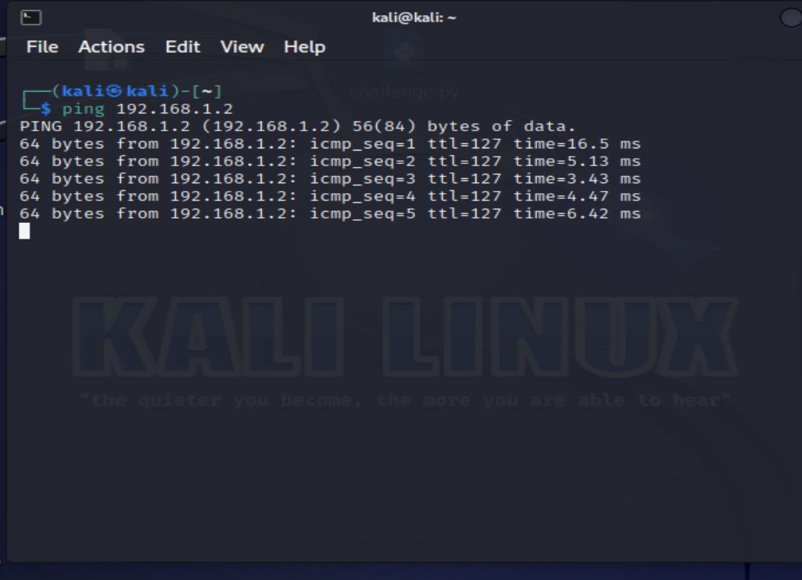

**Step 2:** Block IP address from WAN to a specific target in LAN

Navigate to Firewall -> Rules -> WAN.

Click on "Add".

Action: Block

Protocol: ICMP

ICMP Subtypes: Echo request

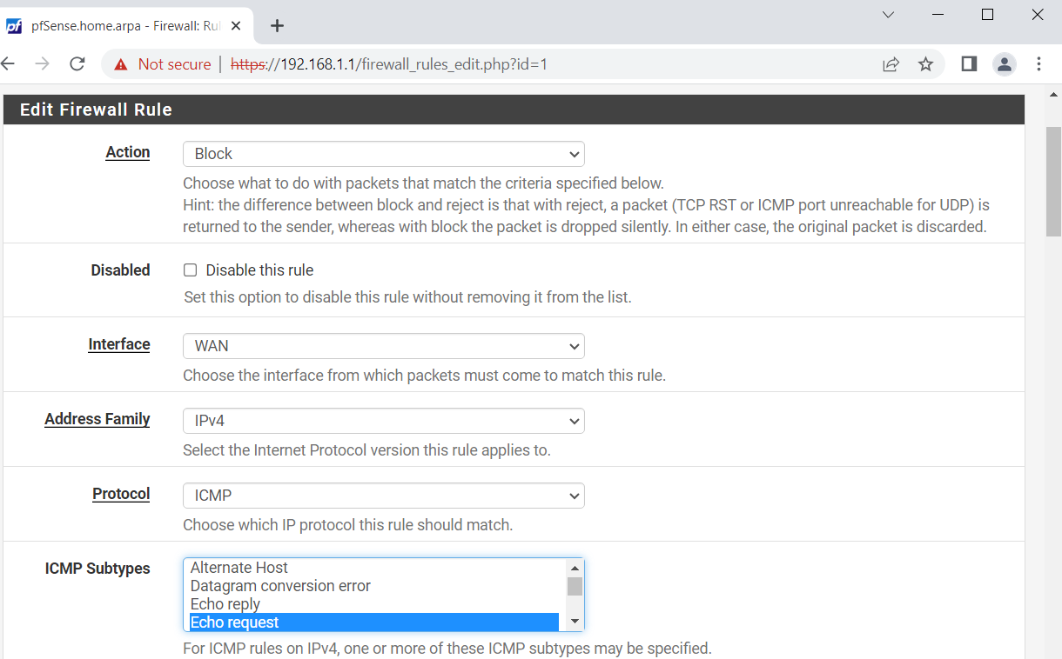

In the Destination field, select "Single host or alias" from the drop-down list, then enter the IP address of the Windows 10/11 machine [192.168.1.2]

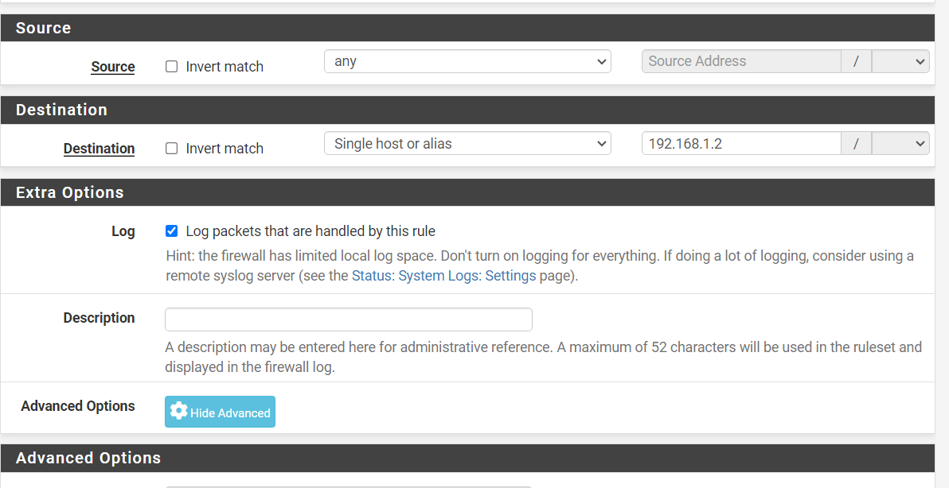

Click on "Save"

Apply Changes

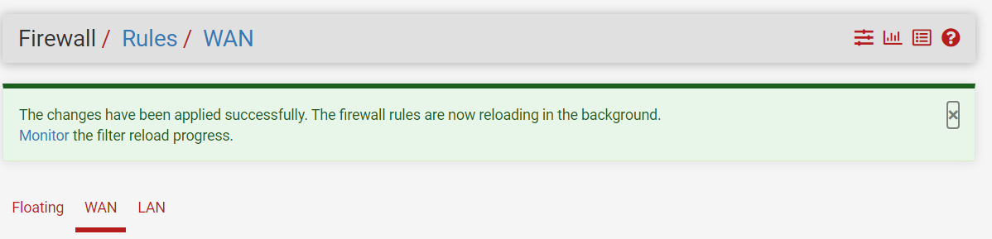

**Step 3:** Ping from Kali Linux to Windows 10/11, you will notice that it does not responding

